Home Built Stirling Engine

Model HK-1 Plans

Runs on almost any fuel
Built with a soldering iron and simple hand tools for less than $20, this engine provides hours of entertainment while demonstrating the Stirling principle and elementary thermodynamics. Harness the power of melting ice using a candle or concentrated sunlight.
These plans are copyright © 2012 by Henry Kroll. You are authorized to make copies of this document for your own use only. Any other use will require permission. Additional information and pictures available: Email admin@comptune.com Revised 12/2012.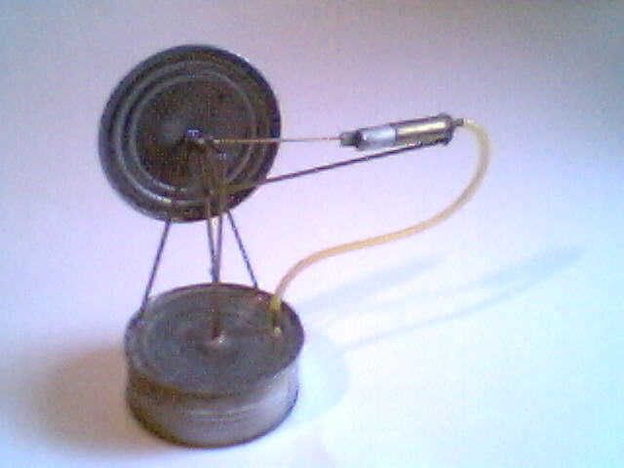
Introduction
The Stirling Engine was patented in 1816 by a clergyman, Robert Stirling. That’s why it’s not spelled ‘sterling’ as in sterling silver... At the time this engine was invented, steam power was commonplace. Possibly some attendees of Stirling’s congregation were affected by accidents and boiler explosions connected with this form of power. Air engines offered a safer and cheaper alternative. What Robert added to the design was a ‘regenerator’ which acts as a heat exchanger and heat recycling device, increasing the efficiency dramatically.
Benefits
Almost anyone can build a Stirling engine: Most designs don’t require complex parts such as spark plugs, injectors, valves or camshafts. There are even designs with only one or two moving parts.
Stirling engines don’t use much fuel: Up to the 50% theoretical maximum thermodynamic efficiency has been achieved with modern designs.
Quiet operation: Stirling engines burn their fuel externally and continuously rather than in a series of explosions.
Versatility: Stirling engines can run on almost any type of fuel, including solar, chemical geothermal and even nuclear. All that is needed is a natural or artificially created heat difference.
Limitations
Low power output: Power is dependent on the thermal expansion coefficient, overall thermal transfer efficiency (R_{th}=°C-in²/W) of the engine, friction and volume of the working fluid (can + cylinder – displacer). The unit described in these plans cannot produce much power due to its low pressure operation and small size. Modern designs overcome these limitations by pressurization of the working fluid and the use of other working fluids with higher expansion coefficients and thermal transfer, such as helium.
Slow Starting: It can take a minute or more for a Stirling engine to get up to speed. In the case of the ‘getaway car’ you may want to have your engine already ‘warmed up’ and running...
Presentation Ideas
There are many handy graphs and equations explaining the Stirling cycle on the internet. Just do a search for “Stirling cycle.” Energy and efficiency graphs comparing Stirling with conventional 4-stroke engines would make a good science fair presentation. Just make sure you understand the formulas or you’re going to have a tough time answering questions!
Parts List

Quan. | Description:
1 ft. | 17/32" x 2” brass tube (Must accommodate piston below snugly but without drag)
1 | ½" x 2" long aluminum, steel or graphite rod. (get one that is a good fit with the above tube)
3 | 1/16" square brass tubing (tubing comes in 1 ft. lengths)
1 | 1/16" brass rod
1 | 3/32" copper tube
2 | cans 4" diameter soup or stew tins (tin plated steel)
1 | plastic tubing that fits snugly over 3/32" copper tube (1 foot length is ok)
1 | 1/4" x 4" x 4" minimum scrap of ceiling tile, stiff fiberglass insulation or basically anything porous, light weight and fire resistant that can easily be cut and formed into a displacer.
1 | fuel: candle, solar dish, kitchen or camp stove, etc for heat source and possibly some water, snow or ice cubes for cooling
Tools
Soldering Iron (40w + recommended) and solder (acid or rosin core)
ball bearing compass or drafting compass/dividers
sand paper or sander
5 minute epoxy (worst), high temp silicone (better) or Devcon® metal patch & fill (recommended)
razor knife and hacksaw or Dremel® cutter
pliers and wire cutters, spray lube
tubing cutter, tin snips, can opener
Get metal rods and tools from local hobby shop. I went to Anchorage House of Hobbies, 2812 Spenard Rd., Anchorage, AK 99503. Hardware stores also carry metal rods and tubes. You can also order them from K&S Metal Center, 6917 W 59th St., Chicago, IL 60638. They also have a website: http://www.ksmetals.com Good quality tin cans are getting increasingly hard to find. Many use thin steel or some type of plastic which would most likely melt… I recommend the thick old-style cans with the shiny tin tops (not the dull enameled ones) since they are easier to solder and you won't have to sand them first. This document assumes you know how to solder.
There is a solder-it kit available at http://www.solder-it.com but I haven't tried it. If anyone decides to use this kit at their own risk and tell me how well (or not) it works, I'd be glad to know. It supposedly allows you to fuse dissimilar metals such as brass to pot metal and offer 5 to 10 times the strength of conventional solder. The cost at this writing is $59 for the kit.
1) Obtain two cans roughly 4" dia. and 1 1/4" tall. Using the can opener, open the cans along the outside of the seam, not the top. This is not the usual way to open a can and may take some getting used to. Save the lids. Be careful as this will leave a sharp edge on the can and you could very well cut yourself doing this!
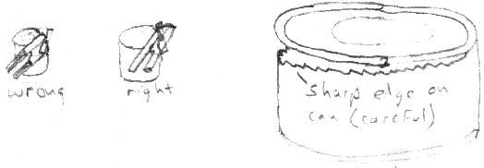
2) Eat the contents or feed them to your cat.
3) Using the tin snips, cut one can down to roughly 1 1/4" tall if it isn't already that height. Taller cans will require longer pistons/rods and more care.
4) Take those lids you saved, and using the compass, find the center point on each. Poke a tiny dimple into the center of both lids with the compass. Poke or drill out a 1/16" hole in one lid and a 3/32" hole in the other. About 1/2" front the edge make yet another 3/32" hole. The tubing should fit snugly into these 3/32" holes for soldering later and the 1/16" rod should also fit snugly in the 1/16" hole in the first lid.
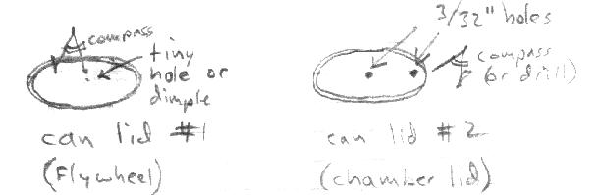

5) Using the razor knife, cut off four 1/2" lengths of copper tube. You could use the tubing cutter also. With the razor knife you will need to use a rolling motion. The finished cut tubes will be crushed slightly inward and you will have to flare them back out with the compass point. Finish off any rough edges with sander or fine sand paper.
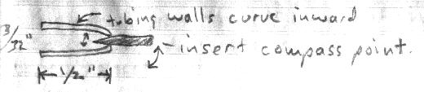
Next, cut and finish three more tubes 1/4" in length. You should now have four1/2" tubes and three 1/4" tubes:
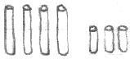
6) Sand around the holes in the can lid and insert two of the 1/2" copper tubes. Solder in place. Be careful not to block the holes! Make sure center tube is perpendicular to the can lid. Alignment is very critical at this stage.
7) Using the wire cutters, cut three 2" pieces of 1/16" brass rod. Don't just snip off with wire cutters, but turn the rod as you apply pulses of gentle pressure: The freshly cut rod should be able to slide easily into the above tubes.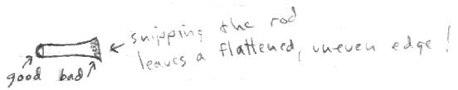
8) Make a displacer by cutting the semi-porous fire resistant material in a circle. Make it small enough to fit easily inside the can without touching the sides. It should move freely up and down. Trim off any excess. Find and mark the center and drill a 1/16" hole through it.
9) You can improve the efficiency of the engine by drilling several more holes in the displacer. This will allow air to pass through easier and that will also help it to recycle some lost energy.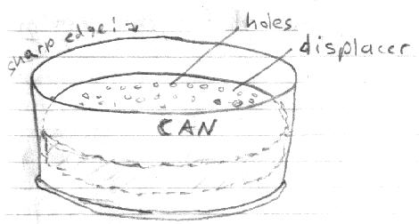
10) Poke the 1/16" brass rod through the displacer and glue in place. Make sure the rod is perpendicular to the displacer surface. Very important! For a longer lasting engine, roughen up the brass rod first, but only in the area contacting the displacer. You can also put thin tin 'washers' on either side of the displacer and solder them in place just in case the glue fails. Note: do not leave a big blob of solder like the diagram below. This will get caught in the seal and reduce free movement of the displacer significantly!
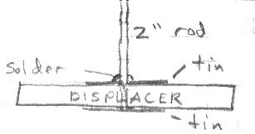
11) Insert the rod and displacer assembly into the top lid you made in step #6. Make sure it moves freely. If not, remove burrs from the copper tube with a compass point. You can now place the lid and displacer onto the can you made in step #9 and put a bead of glue around the top of the can. Alternately, you could solder the entire edge, but this will require lots of sanding. Use high temperature silicone adhesive or Devcon Metal Patch & Fill. I used 5 minute epoxy but was disappointed when it melted when the engine overheated one day. Again, make sure displacer moves freely up and down before glue dries. When the glue does set, be sure to check for leaks! How? Plug the hose into the other open tube and blow into it while applying some soap with a sponge to the freshly glued edge.
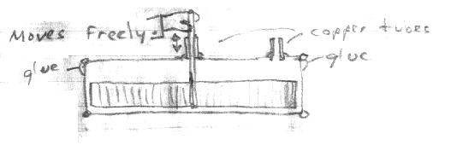
12) Measure the exact distance the displacer can move up and down. This is your stroke.
13) Taking another rod you may now bend your crank. Bend it slightly less than 1/2 your stroke to account for possible error. This is important as too much stroke will cause the displacer to hit the top and bottom of the can, adding to friction and wear.
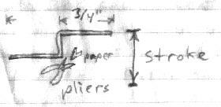
Use notebook or graph paper to check crank: Make sure it is parallel!
Note: Use folded paper in the jaws of the pliers so you don't score the bearing surfaces. Fold several layers of paper... You can also cut and re-solder instead of bending if bending is too difficult.
14) Slide the crank into one of the 1/2" long copper tubes you cut in step #5. Solder flywheel to end of crank. Use extreme care you do not accidentally solder the bearing to the crank in the process!
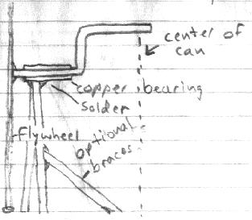
15) Cut two 4" lengths of square tubing and use left over pieces for braces. These will be the two upright braces holding the flywheel and crank up. See diagram below for general layout. Solder braces to crank and to can, making sure everything lines up properly and is square / plumb with can top. Center as best you can. It doesn't have to be exact, but an off-center wobble will make the engine function poorly. The good news is with solder joints you can just heat them and re-adjust. Be careful not to burn yourself!
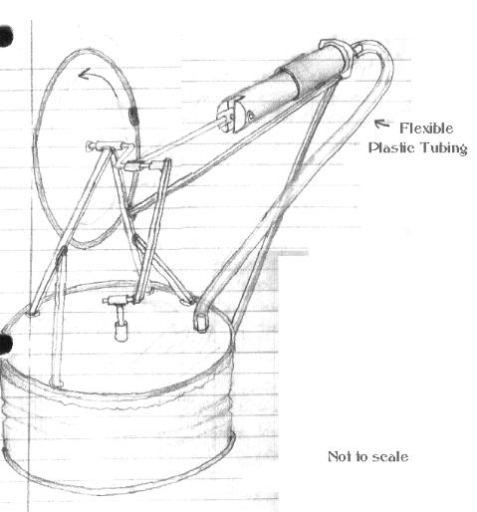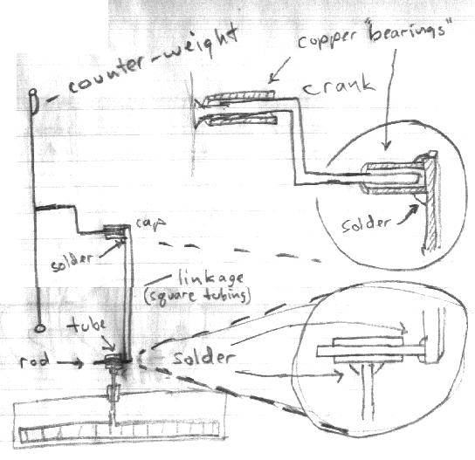
16) Turn crank to the down position. Slip on one of the 1/4" copper tubes. Solder another 1/4" tube to the displacer rod and then connect the two bearings with square tubing. This links the crank with the displacer. Adjust until you can turn crank freely, moving displacer up and down.
17) Slowly turn crank and adjust linkage for minimum friction. Too long a linkage and your displacer will hit the bottom of the can. Too short and displacer will hit against the top of the can. You may wish to add a counterweight to the flywheel by applying a large blob of solder to the rim opposite the crank. You should be able to remove the linkage for demonstration and shipment, but it should stay in place as you rotate the crank.
18) Cut the 17/32" brass tubing about as long as the can is tall (1-1/4"). This will be the cylinder wall. Tubing cutters are OK but they will crimp the tubing slightly. Solder some tin to the cut end. No leaks!
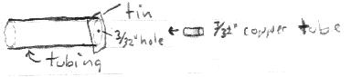
19) Poke a 3/32" hole (or drill) in the tine plate at the end of your "cylinder". Solder a 1/2" length of 3/32" copper tube in the hole. Again, sand the hole first so the solder will stick and check for leaks.
20) Cut the 1/2" aluminum rod to the same length as the cylinder tube. This will be the "piston". Using the hacksaw, cut a slot 1/4" deep in the rough, freshly cut end of your cylinder:
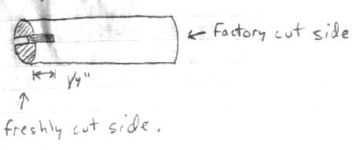
Carefully sand the rough edges. You don't want to score the sides of the cylinder too much or there will be added friction.
21) Drill a 1/16" hole straight through (across) the notch in the cylinder to make a hole for your hinge pin:
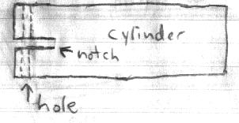
22) Cut a piece of tin and solder a 2" long 1/16" brass rod to it. Put a 1/16" hole in the end. This is the piston rod:
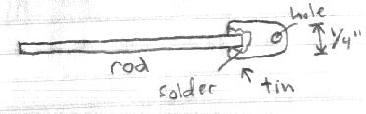
23) Assemble the rod and piston and insert a 9/16" length of brass rod through the holes in the piston. This is your hinge pin. Solder won't stick to the aluminum piston, but you can attach blobs of solder to the ends of the rod to keep it from sliding out. There might be better ways to do this but this worked for me.
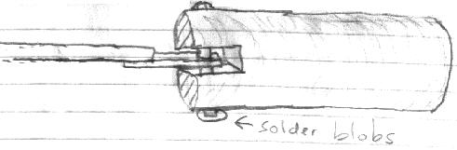
24) Insert the piston into the cylinder. It should move freely in and out. If not, then polish the affected area until smooth. Lubricate with a spray lubricant, light oil or graphite.
25) Using square tubing and solder, mount piston to the side of the engine can in-line with the horizontal center of crank. Things should be starting to look like the picture:
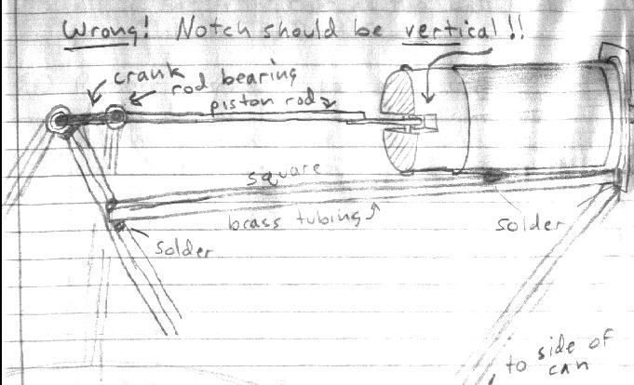
26) Remove the displacer linkage and slip a 1/4" length of 3/32" copper tube over the crank. This is the rod bearing.
27) Calculate rod lengths by turning the crank to the maximum right (horizontal position). Move or push the piston in until it is near the bottom of its free travel into the cylinder. Cut the piston rod to this length and solder it to the rod bearing. Refer to the picture on the past page to see that you have done things correctly. Now there should be free piston travel throughout the entire turn of the crank. If not, adjust linkages until it runs as smoothly and freely as possible.
28) Replace displacer linkage and connect plastic tubing from the air chamber to the piston. It should slip snugly over the copper tubing with no leaks.
29. Turn crank and check for easy piston and displacer movement. Engine is now ready to run. Lubricate all moving parts. Do not use heavy oil or grease. WD-40® works, but it eventually turns to grease, which will hamper performance.
Apply heat to the bottom. An electric range works very well. You can also use a gas stove on low, a candle, or even a cigarette lighter or focused sunlight. You may need to put a small ice cube on top to keep it cool. The additional cooling will make it run faster. Apply low heat for a minute, then gently turn the crank counter-clockwise to start engine. Remove from heat to shut off. CAUTION! The engine can get quite warm and it’s possible to burn your fingers. Wear oven mitts or heavy gloves. Another thing you could do is take some scrap tin and make a “handle” to hold the engine but be sure to round the edges so they’re not sharp. Don’t let the engine get too hot or it might melt the solder. It should be able to run at temperatures well below that point!
Additional Notes: The first prototype was very well machined to exact tolerances. It did not work. A tiny bit of air must be able to leak through the displacer rod seal. If no air can escape from the engine then the piston will seize in the out position during warm-up due to expanding air inside the can. Built with these handy materials the amount of leakage should be ideal (depending on how much lubrication is used. Too much lubrication will plug the seals entirely and make for hard starting.) Loose fitting parts also guarantee less friction. Engine must be able to spin freely or it will have trouble working.
Advanced Projects: Connect another piston to the other side. Presto, a heat powered air pump. With a slight modification, the cylinder can be made to flip over to the other side, making the engine run in reverse. Extend the shaft and attach fans or pulleys to it and make it do work. How about a candle powered paddle wheel boat? Extend the crank and add more cans and pistons. A two cylinder engine should be almost self-starting! Can you figure out the right crank angle to make it run smoother? Try making a solar collector...
Have fun!

